Toilet Training
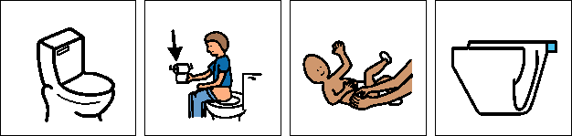
Here are some helpful tips for toilet training:
Autistic children may take longer than other children to learn new skills so need a calm, consistent approach and commitment to continue working with them for as long as they need. It is helpful if everyone follows the same routines and starts the process at the same time. Good communication between family and professionals (e.g. child minders and teachers) is important

- Look for the first signs that your child could be ready to use the toilet, e.g. if they are pulling at their nappy or aware when they are wet.
- Some children may not show these obvious signs in this case it may be helpful to keep records of the child’s drinks, wees and poos for a few days to provide information about their normal pattern for passing urine and opening their bowels. Using this knowledge take the child to the toilet at times when they are most likely to need to go to help establish the link between the cause (feeling the physical signs of toileting) and the effect.

- Choose a time when you have few engagements and are feeling relatively stress free a school holiday may be a good time
- Make sure everyone who works with the child will start toilet training at the same time and follow an agreed approach.
- Change the child’s nappy in the toilet so they get used to the routine of knowing where it happens.
- Autistic children tend to like a routine. Teach the child a whole routine right from saying “toilet time” to washing and drying hands, rather than just sitting on the toilet. Keep the sequence the same every time so the child knows what happens now, next and what is expected of them.
- Many autistic children are visual learners: they understand and learn more easily if pictures are used to help explain what is required. Social stories can be used at a time when the child is relaxed, to introduce what will be expected in toileting before toilet training and then used before the child is taken to the toilet.
- A visual instruction strip or Jig may be helpful as it breaks down the toileting routine into smaller steps allowing the child to see and follow each stage in the sequence.
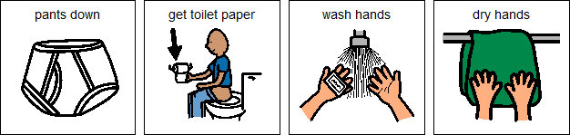

- Make it fun: use something motivating in the toilet to help as a distraction if your child doesn’t like sitting on the toilet/being in the bathroom, e.g. bubbles, favourite story/ toy. Praise- have something ready to motivate your child straight away once they have done something, e.g. sticker/ chocolate button for just sitting on the toilet could be the start. Tell the child needs to be exactly what they are being rewarded for: ‘Well done Joe, you wee’d in the toilet’. The reward should only be used for toileting and its use should be avoided for three or four days before toilet training is started.
- Some children may have differences in their sense of Interoception, the internal feeling that they need to eat, drink or go to the toilet. In this case introducing toilet breaks at regular and consistent times of the day, provides a routine for toileting reducing the risks of ‘accidents’ many autistic adults do not feel the need to go to the toilet so will schedule toilet breaks into their day or use phone reminders to prompt them to go to the toilet.
STARS Resources
Examples of toileting Social Stories
Example of a Gif to support toileting with symbols for girls and boys
Symbols to support Hygiene routines

Some other useful resources

Parent toilet skills booklet: www.continencevictoria.org.au/sites/default/files/Booklet.pdf

